

**Green University of Bangladesh**

**Department of Computer Science and Engineering (CSE)**

**Faculty of Science and Engineering**

**Semester: (Summer, Year:2021), B.Sc. in CSE (Day/Eve)**

**Course Title: Computer Networking Lab**

**Course Code: CSE 312 Section: 201ED**

**Lab Project Name: Wireless networking in cisco Packet tracer [simulator]**

**Student Details**

|  |  |  |
| --- | --- | --- |
| **Name** | | **ID** |
| **1.** | **MD Shahrior Shawon Prio** | 192002032 |
| **2.** | **Mamun UR Rashid** | 201015066 |
| **3.** |  |  |

**Submission Date : 04/09/22**

**Course Teacher’s Name : Shimul Dey kotha**

**[For Teachers use only: Don’t Write Anything inside this box]**

|  |
| --- |
| **Lab Project Status**  **Marks: ………………………………… Signature: .....................**  **Comments: .............................................. Date: ..............................** |

Table of Contents

Chapter 1 Introduction 3

1.1 Introduction 3

1.2 Design Goals/Objective 3

Chapter 2 Design/Development/Implementation of the Project 4

2.1 Section (Choose the name of this section as appropriate with your project) 4

2.2 Section (Choose the name of this section as appropriate with your project) 4

2.2.1 Subsection 4

Chapter 3 Performance Evaluation 5

3.1 Simulation Environment/ Simulation Procedure 5

3.2 Results and Discussions 5

Chapter 4 Conclusion 6

4.1 Introduction 6

4.1 Practical Implications 6

4.2 Scope of Future Work 6

References 7

# Chapter 1 Introduction

## Introduction

## Providing broadband access to citizens, communities, public institutions and developing businesses has become a strategic objective for governments and international organizations worldwide. Serious problems related to the “digital divide” have been widely recognized by public administrations. However, the solution to these problems is not straightforward.

## Design Goals/Objective

## Our objective is to design a wireless communication system which will help Applications that drive the development of community networks can be

group as follows:

1. Access to public information and services

2. Public safety

3. Traffic control and transportation

4. Health care

5. Business services

6. Educational

7. Utility companies (electricity, water, gas, etc.)

# Chapter 2

# Design/Development/Implementation of the Project

## Theory: Wireless networking is a method by which homes, telecommunications networks and business installations avoid the costly process of introducing cables into a building, or as a connection between various equipment locations. Admin telecommunications networks are generally implemented and administered using radio communication.

## Used Component:

## 1. Laptop and Desktop

## 2. Router

## 3. Switch

## 4. Server DNS

## 5. SERVER HTTP

## 6. Access Point-PT

## 7. Wires

## 2.2.2 Methodology:

# Chapter 3 Performance Evaluation

## Simulation Environment/ Simulation Procedure

Screenshot:

**Router:**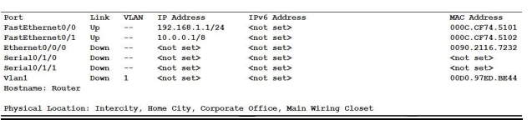

**Router IP configure: FastEthernet 0/0:**

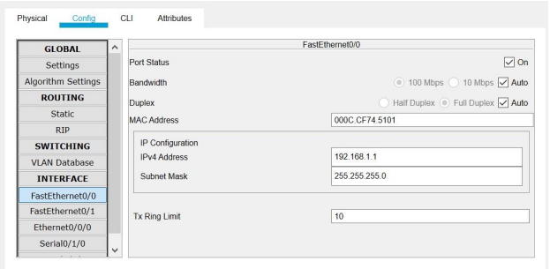

**Router IP configure: FastEthernet 0/1**

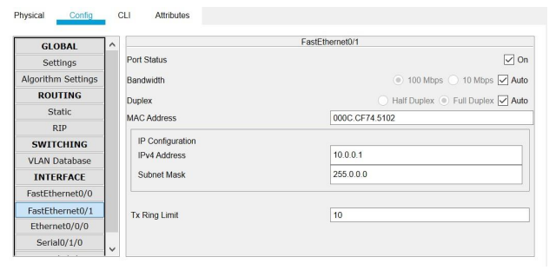

**Routers connect with WIC 2T port:**

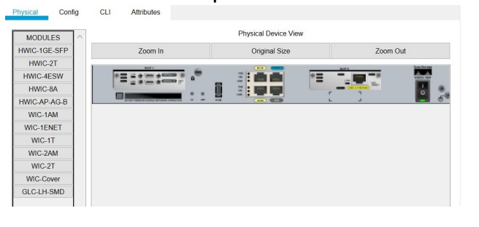

**Access Point: Dark_Host_male:**

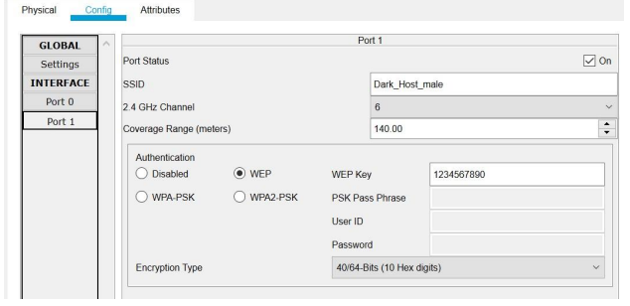

**All PC Setup WMP300N port for wireless network connection:**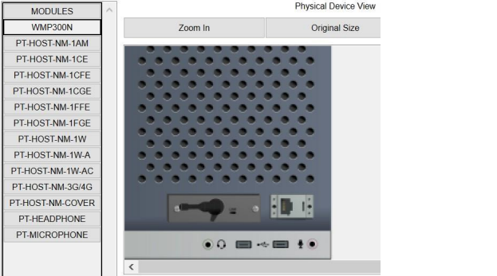

**PC0 IP config:**

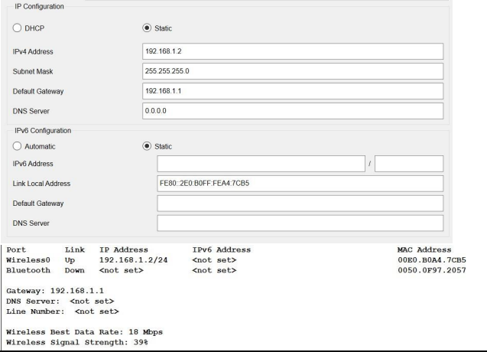

**PC12 IP config:**

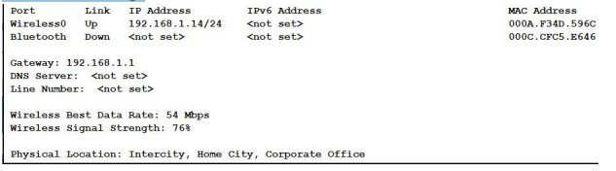

**PC13 IP config with DNS setup:**

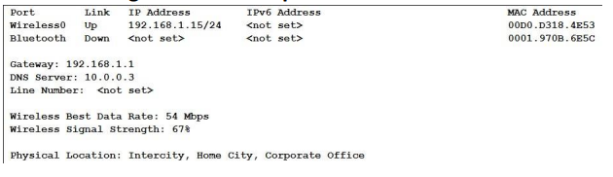

**PC0 wireless setup:**

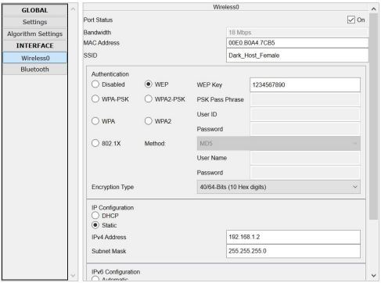

**All wireless network list:**

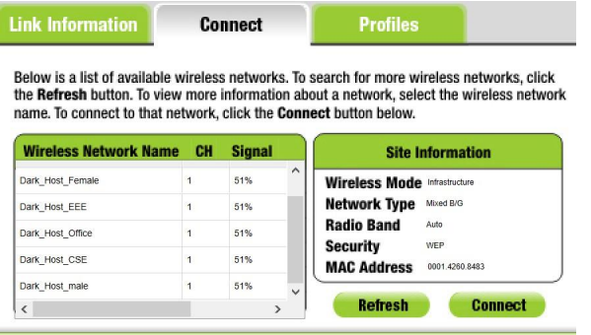

This is wireless network list. There are five-access point for wireless

connection for pc. I can connect any wireless network in any pc using correct

password.

**Let’s See the full building blocks:**

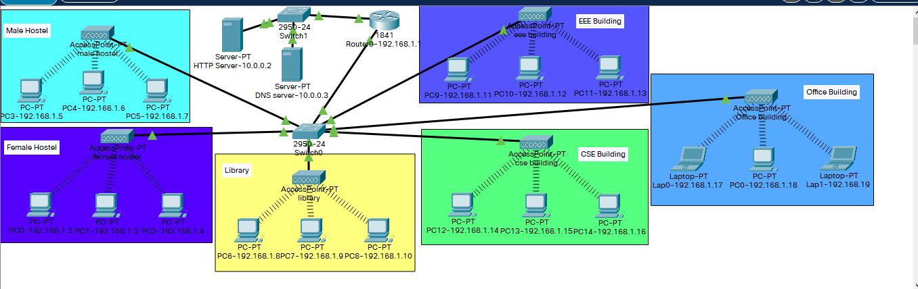

## Results and Discussions

* + 1. **Results**

**Ping hostname:**

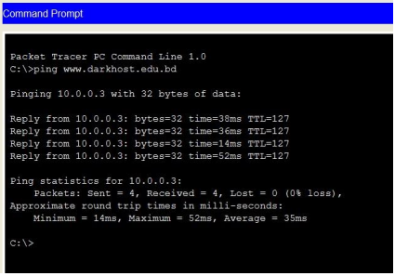

**Ping pc3 ip:**

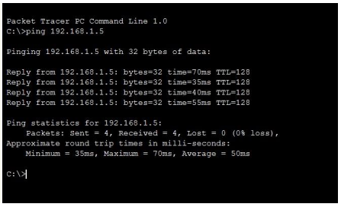

**HTTP browser output:**

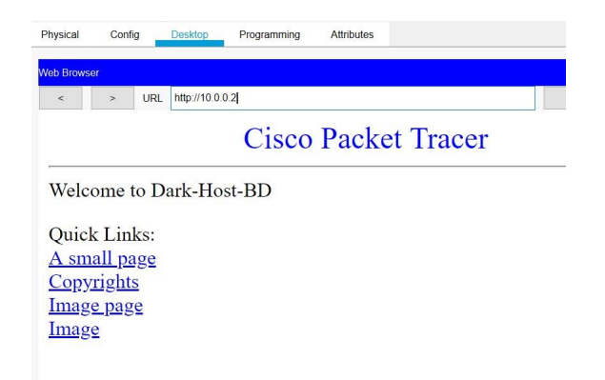

**Successfully send Message pc to another pc:**

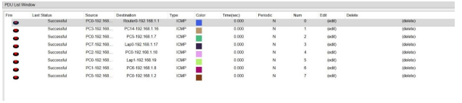

# Chapter 4 Conclusion

## Limitation

## The cabled or wired network provides a much faster rate of file

## sharing than the wireless network.

## Due to physical and technological limitations, wireless networks can

## transfer data up to a certain capacity.

## The speed of wireless devices, in general as compared to a cabled

## connection, decreases as the user gets away from the router or WiFi source.

## Household items and interiors, such as the fridge, windows panes,

## walls, ceilings, can obstruct the signal of wireless systems.

## These things could deflect the signals or make it weaker.

## Setting up a wireless network could be a bit troublesome at times.

## Practical Implications

Finally, we are finish all work this project.

## Scope of Future Work

* + - When we are working on this project so there are facing many problems.
    - In future, we are trying to solve all limitation and problem.

# References

1. Most of them are from lab practices and lab manuals.
2. The practices we did from the labs.
3. [www.youtube.com](http://www.youtube.com)
4. [www.stackoverflaw.com](http://www.stackoverflaw.com)